Introduction

A project we aim to develop is creating the main key point for devices in Greenwich university . The reason we choose this topic because cyber security has been the main problem in many careers in our life. Any risk of data that run through in our organization can make a huge damage to our benefit and the development to our career in the future so the key point to lock our important information can be necessary right now. This project also is also the update to deeper in our daily life. Protecting our private space in real life is not enough but we also must focus to more different of life such as cyber environment so people can understand more about technology

**P1 Devise project aims and objectives for a chosen scenario.**

1. The aim of project

This aim of this project will be very simple but these task are made to help our awareness of cyber protection to higher level.

- finding out the possible risk that can appear in process of transporting data

- creating new more effective solution in protecting information

- improving the user knowledge in the threat happen around them in cyber space

- finding out more effective solution for risk may happen

2. objective of project

Project objectives are the things you hope to accomplish by the project's conclusion. Deliverables and assets could be mentioned here, as well as more abstract goals like raising motivation or productivity. Your project goals should be measurable outcomes that are achievable, time-bound, and explicit. For short understanding, the objective is the outcome from separate of many parts in our process and it must follow SMART forms:

1. Specific (simple, sensible, significant).
2. Measurable (meaningful, motivating).
3. Achievable (agreed, attainable).
4. Relevant (reasonable, realistic and resourced, results-based).
5. Time bound (time-based, time limited, time/cost limited, timely, time-sensitive).

This is the list of objectives that we expect to claim for building the success project

* We can finish 50% of coding process in two weeks and it can be finish full process 100% in next 3 weeks. We want to stick to this schedule to make sure our code to work smoothly and less bug as possible.
* We will interview about 100 people about their experiences in project in 2 weeks so we can find out pro and con of our system.
* We are going to run our the end-lock system to specific places in school or work place in 3 weeks and let user try it in 2 weeks to find out how it affect to user behavior and we fix any problem occur during the process.

**P2 Produce a project management plan that covers aspects of cost, scope, time, quality, communication, risk and resources.**

1. scope of project

1.1 mission project aim to do

* This project focuses on analyze the potential threat to safety of information in close environment
* This project is only made for student in school or employment in work place and it only work in specific building
* The surveys are just for student and employees experiences to finding out the impact from project.

1.2 what is not aim to do in project

* There is no interfering of outside activity that can affect to only close user environment.
* People who are outside the specific place for interact with project will have no permission to try it

2. project time limit

The management of time spent and project task and activity progress is known as time management. Planning, scheduling, monitoring, and managing all project operations are necessary for effective time management. According to the Project Management Institute, one of the six key functions of project management is time management. Some people also refer to the methods and tools for managing time when they talk about project time management.

Time limit for activities

Setting up the suitable place for running project: 1 week

Discussing for idea which will be includes in project: 1 week

Creating source code with specific platform: 3 weeks

Launching project on user environment and making a survey form user: 2 weeks

Summarizing all result to find out the real impact and problems to be fixed: 1 week

Total time: 8 weeks -> 2 months

3. communication plan

A policy-driven strategy for informing stakeholders is a communication plan. The strategy formally specifies who should receive specific information, when it should be supplied, and through what channels it will be communicated. A policy-driven strategy for informing stakeholders is a communication plan.

The main target will receive information: students, teachers and employees around the school. They will know what will include in platform that they interact with. They will interact with the program and they give us back which is perfect or big the issues need to fix.

The timeline for launching project: it will be launched after its platform finish. Everyone in main target can use it until the summary of survey

Channels to communicate: internet and mobile device will be all the main bridge for all user. They use these channel to work with project and they will use all recommend function that already adding into project by creators interaction. They also can use it to send some report of project such as its problems or suggestion.

4. risk plan

The process of determining, prioritizing, and managing risk is known as risk planning. Every project or effort has goals, or objectives, which are the things it wants to achieve. They are frequently known as Critical Success Factors (CSF). Risk factors pose a threat to the accomplishment of these crucial success factors.

|  |  |  |
| --- | --- | --- |
| risk | frequency | Effect to project |
| System malfunction | usually | Extreme bad |
| Low performance | frequently | Extreme bad |
| Over cost | sometime | bad |
| Not enough resources | sometime | bad |

5. resources for plan

The efficient and effective utilization of the many resources connected to a project is referred to as resource management. A resource management plan details how all of the resources you'll need for a project—people, workspaces, tools, and equipment—will be organized, distributed, managed, and released.

Human resources: 3 person

This is not the big public project so we do not need huge amount of groups members to do it. 2 people will focus to build the platform and the last one will focus on communicate with users

Devices: phone, desktop computer and laptop are used to build and test code before it get release for users. It require good hardware to make sure all processes go well.

6. cost of project

The sum of all expenditures related to a project that are funded by long-term financing is represented by the cost of the project. The cost of the project must be precisely evaluated because underestimating expenditures would result in a lack of funding.

For human cost: this is just a small project for finding the impact of technology to users so and we can use some of our own so there are no cost about this

For devices: it will cost around 1500$ for desktop pc because we want to have the last technology with stable performance. Phone and laptop will cost around 2000$

P3 Produce a work breakdown structure and a Gantt Chart to provide timeframes and stages for completion.

1. work breakdown structure

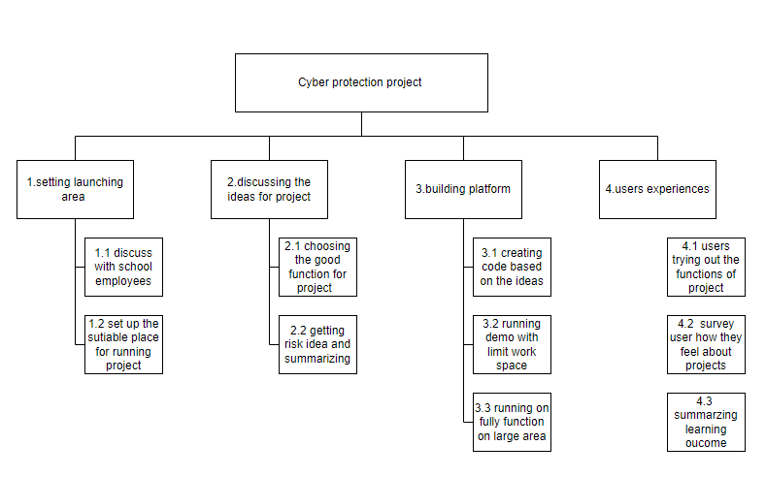

2. Gantt chart

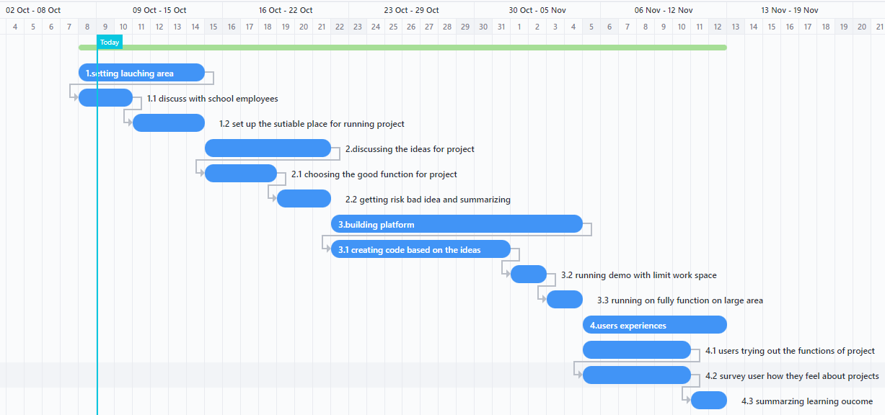

P4 Carry out small-scale research by applying qualitative and quantitative research methods appropriate for meeting project aims and objectives

1. primary research

Who: The main subjects will be interviewed that are students and employees in Greenwich

What: about the knowledge of technology impact and their experience about project

Why: this is help us to find out that our project has go well or not and this helps users to understand more about technology

When: in the last week of project schedule because this is when our platform has been finished

Where: in Greenwich university, this is where we set up our project so let everyone in school have permission to join

1.1 interview question

Open question:

* What do you know about computer technology ?
* Can you tell us about endpoint devices ?
* How smart devices has affected to our social life ?
* What is the most advantage you can see in smart devices ?

Close question ?

* What you know about cyber security ?
* Our school have a lot of people so do you worry when you are sharing your internet information around them ?

1.2 summary about interview

After the interview, we see that most of participants have very basic understanding about info technology in internet interaction. However, some of them have fascinating answer. These help us to realize that even we use smart devices our awareness of the danger of cyber attack is not enough. They give us the answers that are not fully thinking the sequence about bad result through using bad wed site or bad using deices habit which can make cyber attack easy to occur. Some result we can find out:

* Not fully understand the pro and con of smart devices and internet
* People need to find more information because they have very limit knowledge

1.3 List of survey questions

The survey is important to our project because it is relatively inexpensive. Particularly for online and mobile surveys, the cost per respondent is quite low. The cost per response is frequently far lower than the cost of delivering a paper survey or a phone poll, and the number of potential responses might reach thousands. Even if incentives are provided to responders. Respondents are able to provide more honest and accurate replies due to the anonymity of surveys. You need responders to be as candid and open with their responses as you can in order to collect the most accurate data. Compared to other research approaches, surveys that are done in an anonymous manner give respondents a chance to give direct, straightforward answers, especially if it is made clear that survey replies will be kept entirely confidential.

List of question for a survey:

* How is affective of our project after you try it ?
* What is the perfect that we have done great about the system ?
* What point that you see it is still not good ?
* What are new functions that we should consider to apply ?

1.4 summary about the survey

After the summary, we see that our project has made good expression to most of people in school. However, our project is still making some people concern a lot because its effectiveness in long-term use or the problems occurs during the process. 60% of participants is very satisfied fine with the projects, 35% consider its quite bad and 15% is not very enjoy the projects

1.5 Evaluation about interview and Survey

After the interview and survey, this project helps participants understand more about how technology impact to their daily life and they gain more experience about their cyber security which help them to notice their safe in cyber space. The most success point of interview and survey is giving good experience for participant because of that they can see the good impact of technology to our life but still no what should be prevented. Moreover, this help us to find down the weakened in our project so we can improve it in the future for better performance.

2. secondary research

2.1. action for research

The secondary research will activities as same as the first but we will do some change to make participants be better. We don’t focus on giving question too much anymore. We give them some example of our project first and let them play some game help them to get fun while give them more knowledge about cyber space. Moreover, we will use more about professional documents to gain better understanding about the problems we face on our project.

Advantage: we can have more comfortable research with less exhaustion when work with participants. We also have more reliable evidences and resources to our view in project

Disadvantage: it takes more time and resources of people to find out the good solution for our problems and the research can be go wrong path if it get stuck bad sources

2.2. List of articles /books

6 common project management mistakes — and how to avoid them: <https://www.cio.com/article/286668/8-common-project-management-mistakes-and-how-to-avoid-them.html>

8 goals every project manager should aspire to achieve: <https://www.cio.com/article/280361/project-management-goals-every-project-manager-should-aspire-to-achieve.html>

How to Become a Project Manager: 6 Steps <https://www.coursera.org/articles/how-to-become-a-project-manager>

2.3 Summarize about articles/Books you have read

The first article gives a list of critical mistakes can happen in our projects. It shows all the problems that can bring into our performance. It also shows the readers the result of these mistakes and how it impacts into our career. However, they also write the solutions to prevent these mistakes happened in the future. Giving us some advice to help us keeping out form the problems.

The second article is about the goal that beginner must gain to lead to the success project.